RB02- Bastion Host (for private resources)

- Create VPC
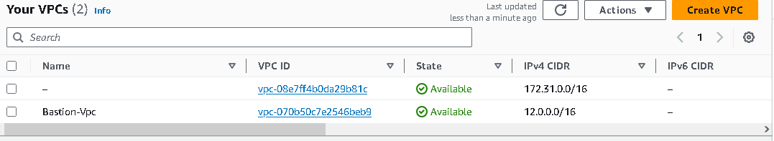
- Create public 2 subnets(one in public subnet and one in private subnet)
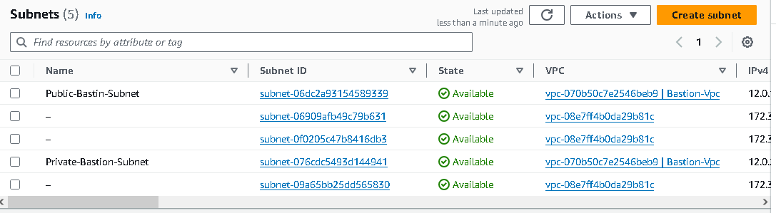
- Create Route table & associate it with both subnets & edit route of public subnet
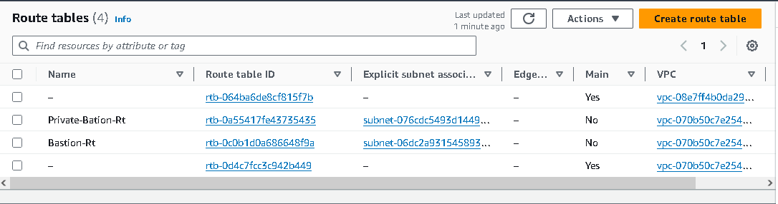
- Create IGW & Attach it to first VPC
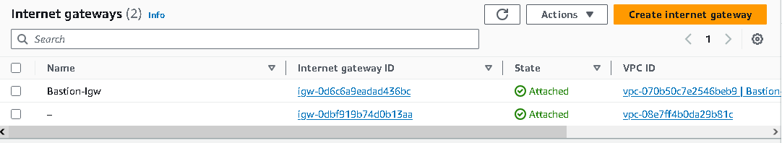
- Launch two instances ( public and private)
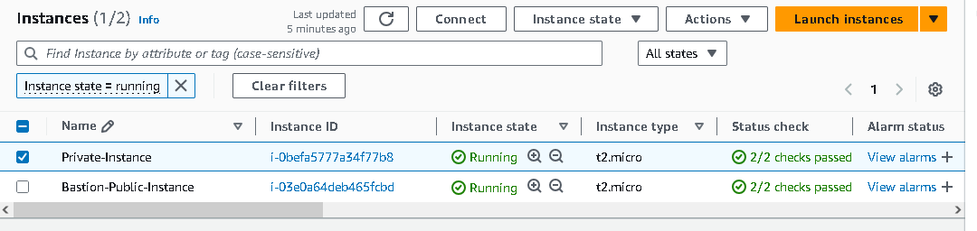
- Select AMI for the instance
- Select instance type
- Create or select key pair
9. Network configuration:
*Select VPC, subnet preference public subnet and auto assign IP is Enable
*Select VPC, subnet preference private subnet. and auto assign IP is Disable(because it has no internet connectivity)
- Security Rule
*Create security rule of 22 to ssh for public instance
*Create security rule of 22 to ssh private instance but the source type will be CIDR block of Public subnet.
Testing Setup
From local terminal ( for public instance)
Locate key.pem
chmod 400 “ key”
ssh -i “key“ AMI@public ip
For private instance
create a new file to store that key using “touch” command
using vi editor copy that key into it
chmod 400 new file( in which your key is located)
ssh -i new file(key) AMI@private ip of private instance.
